# **HW7 - PKI Infrastructure and Web Server**

**Name: Nihar Patel**

**ID: 019158958**

**Name: Kalhar Mayurbhai Patel**

**SJSU ID: 019140511**

**Name: Deep Bharatbhai Dhaduk**

**SJSU ID: 018317078**

**GitHub URL :-** [**https://github.com/Nihar4/HW-7---Security**](https://github.com/Nihar4/HW-7---Security)

## 1. Introduction

**This assignment demonstrates the design and implementation of a complete Public Key Infrastructure (PKI) with three levels: Root Certificate Authority (Root CA), Signing Certificate Authority (Signing CA), and a TLS Server Certificate. The infrastructure was built using OpenSSL, and a secure web server was configured to use the generated certificates. This document presents the step-by-step process with screenshots showing the implementation and verification.**

## 2. PKI Infrastructure Setup

### 2.1 Initial Project Setup

**The project directory was created with organized folders for PKI components and the web server.**

**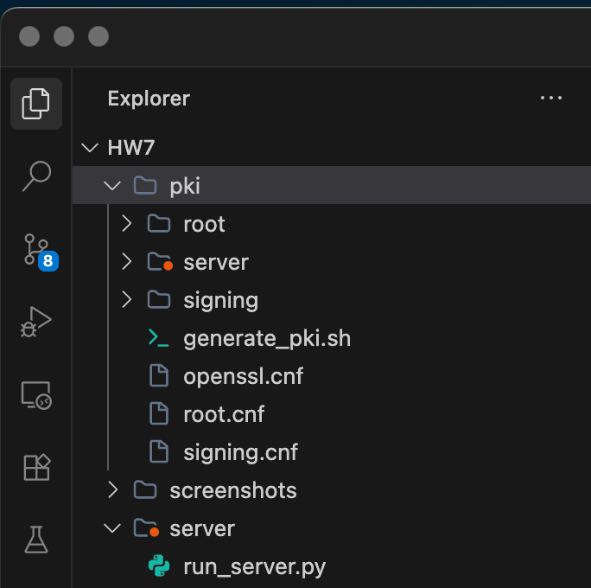  
*Figure 1: Initial project directory structure***

### 2.2 Certificate Generation Script

**A bash script (generate_pki.sh) was created to automate the entire PKI generation process. This script: - Creates Root CA (self-signed) - Creates Signing CA (signed by Root CA) - Creates Server Certificate (signed by Signing CA) - Verifies the certificate chain**

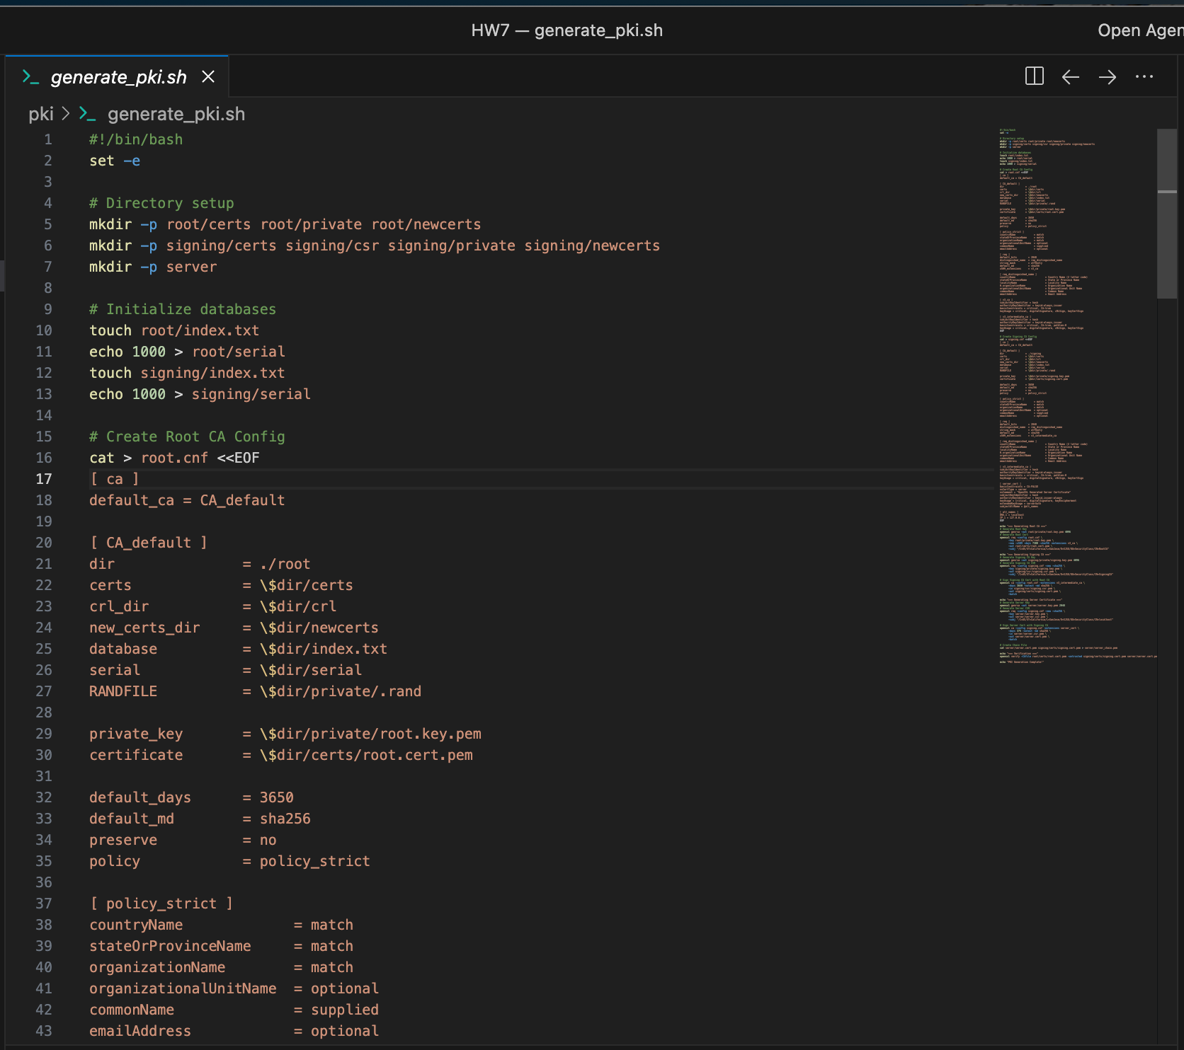

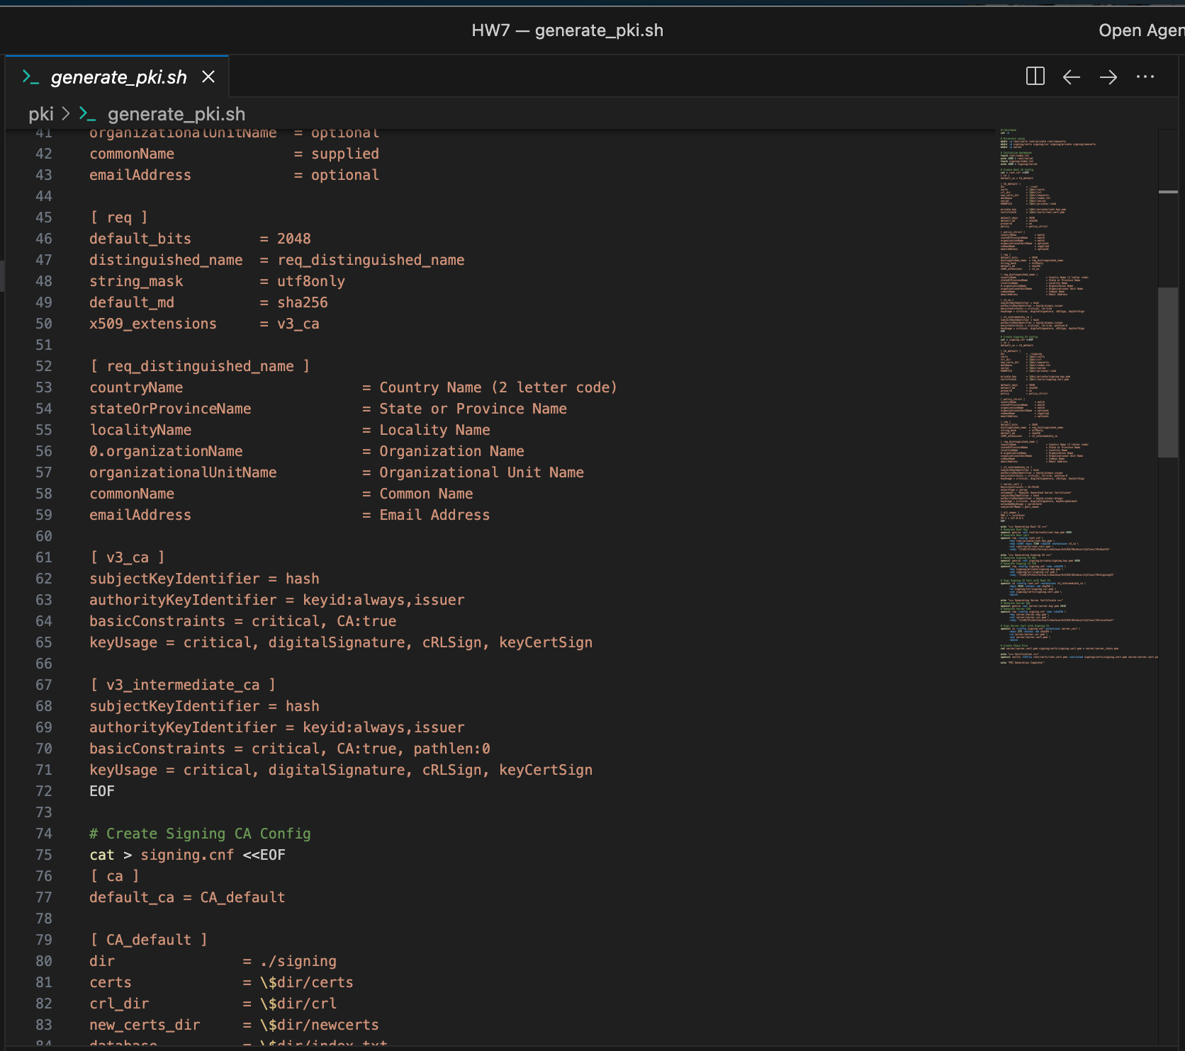

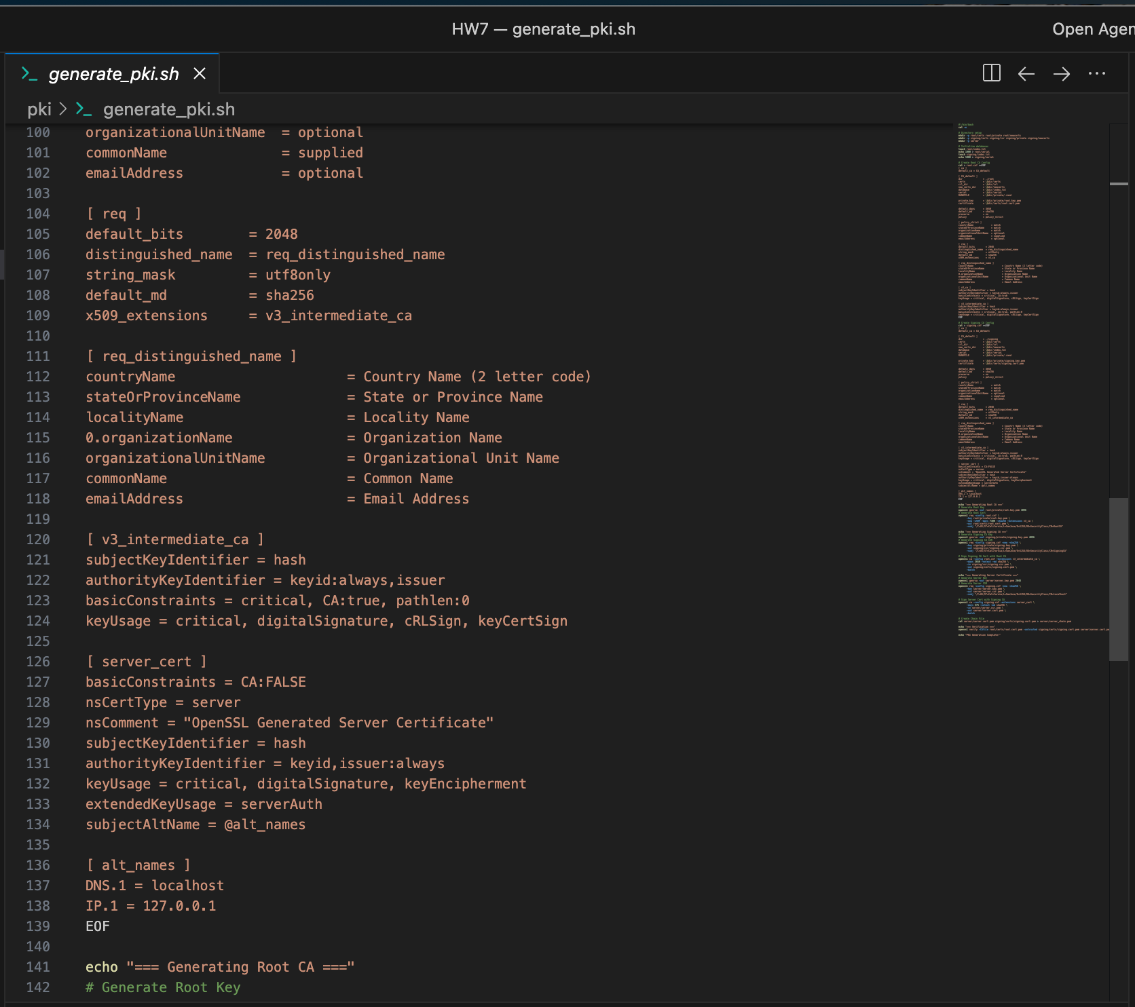

**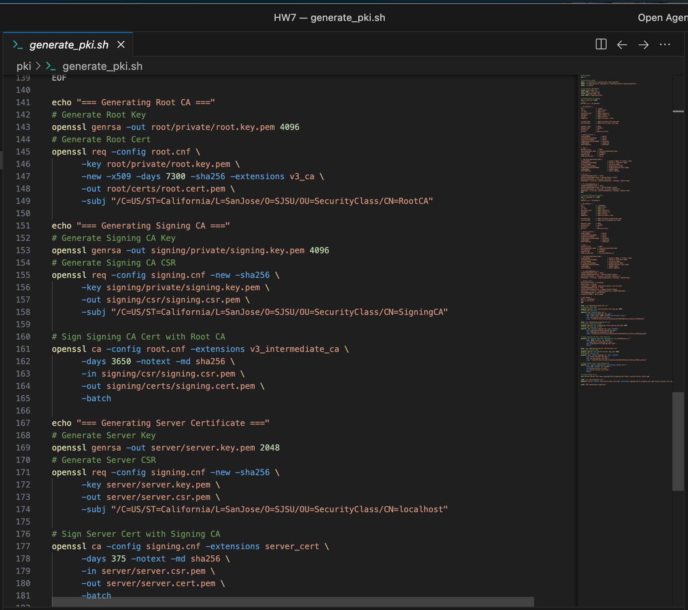  
*Figure 2: PKI generation script (generate_pki.sh)***

### 

### 

### 

### 

### 

### 

### 

### 

### 

### 

### 2.3 Generating the Certificates

**The script was executed to generate all certificates and keys:**

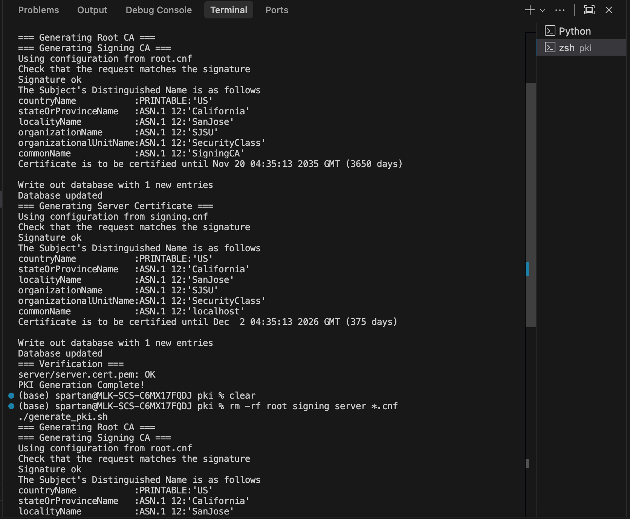

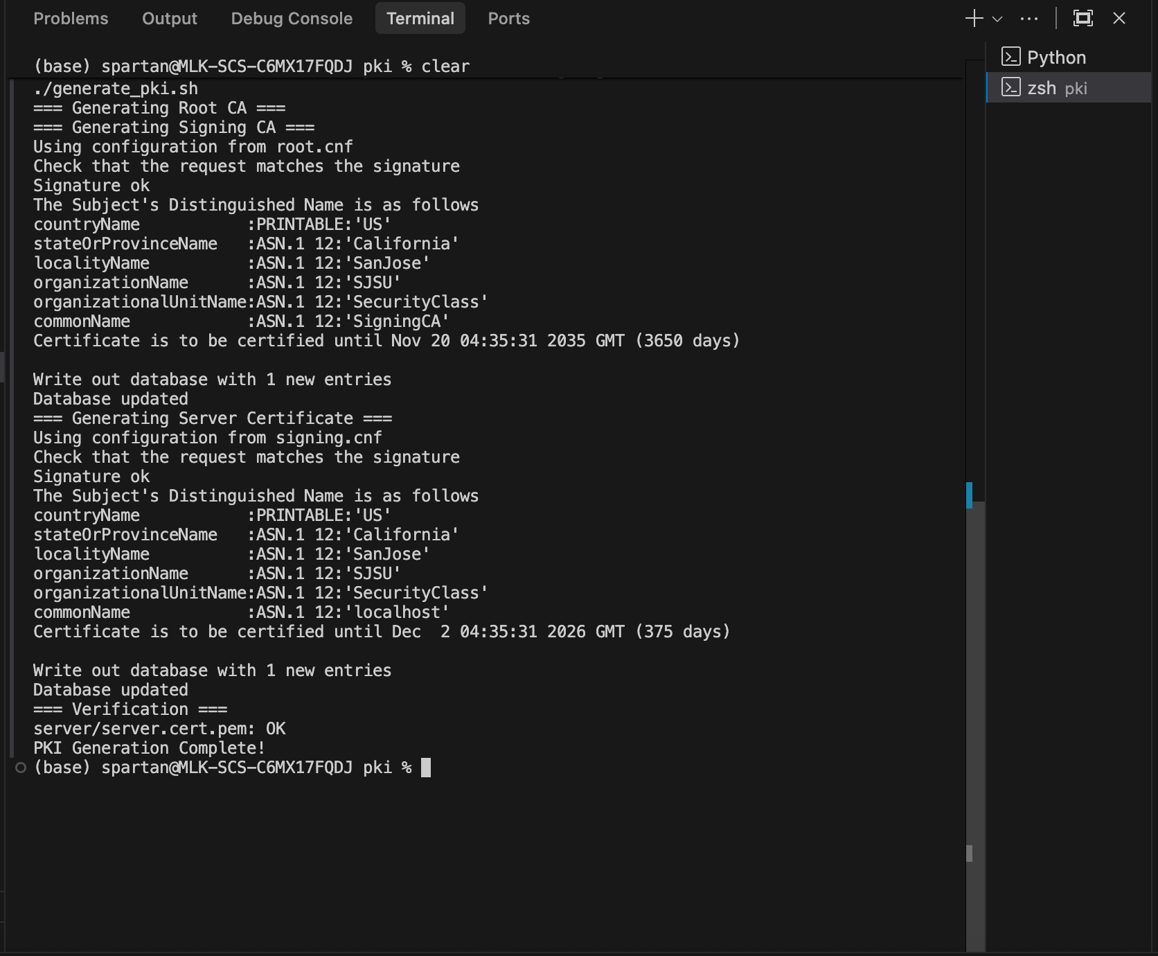

***Figure 3: Certificate generation process output showing successful creation of all three certificate levels***

**The output confirms: - Root CA generated successfully - Signing CA created and signed by Root CA - Server certificate created and signed by Signing CA - Certificate chain verification passed**

### 

### 

### 

### 

### 

### 

### 

### 

### 2.4 Generated Certificate Files

**The following files were created during the PKI generation:**

**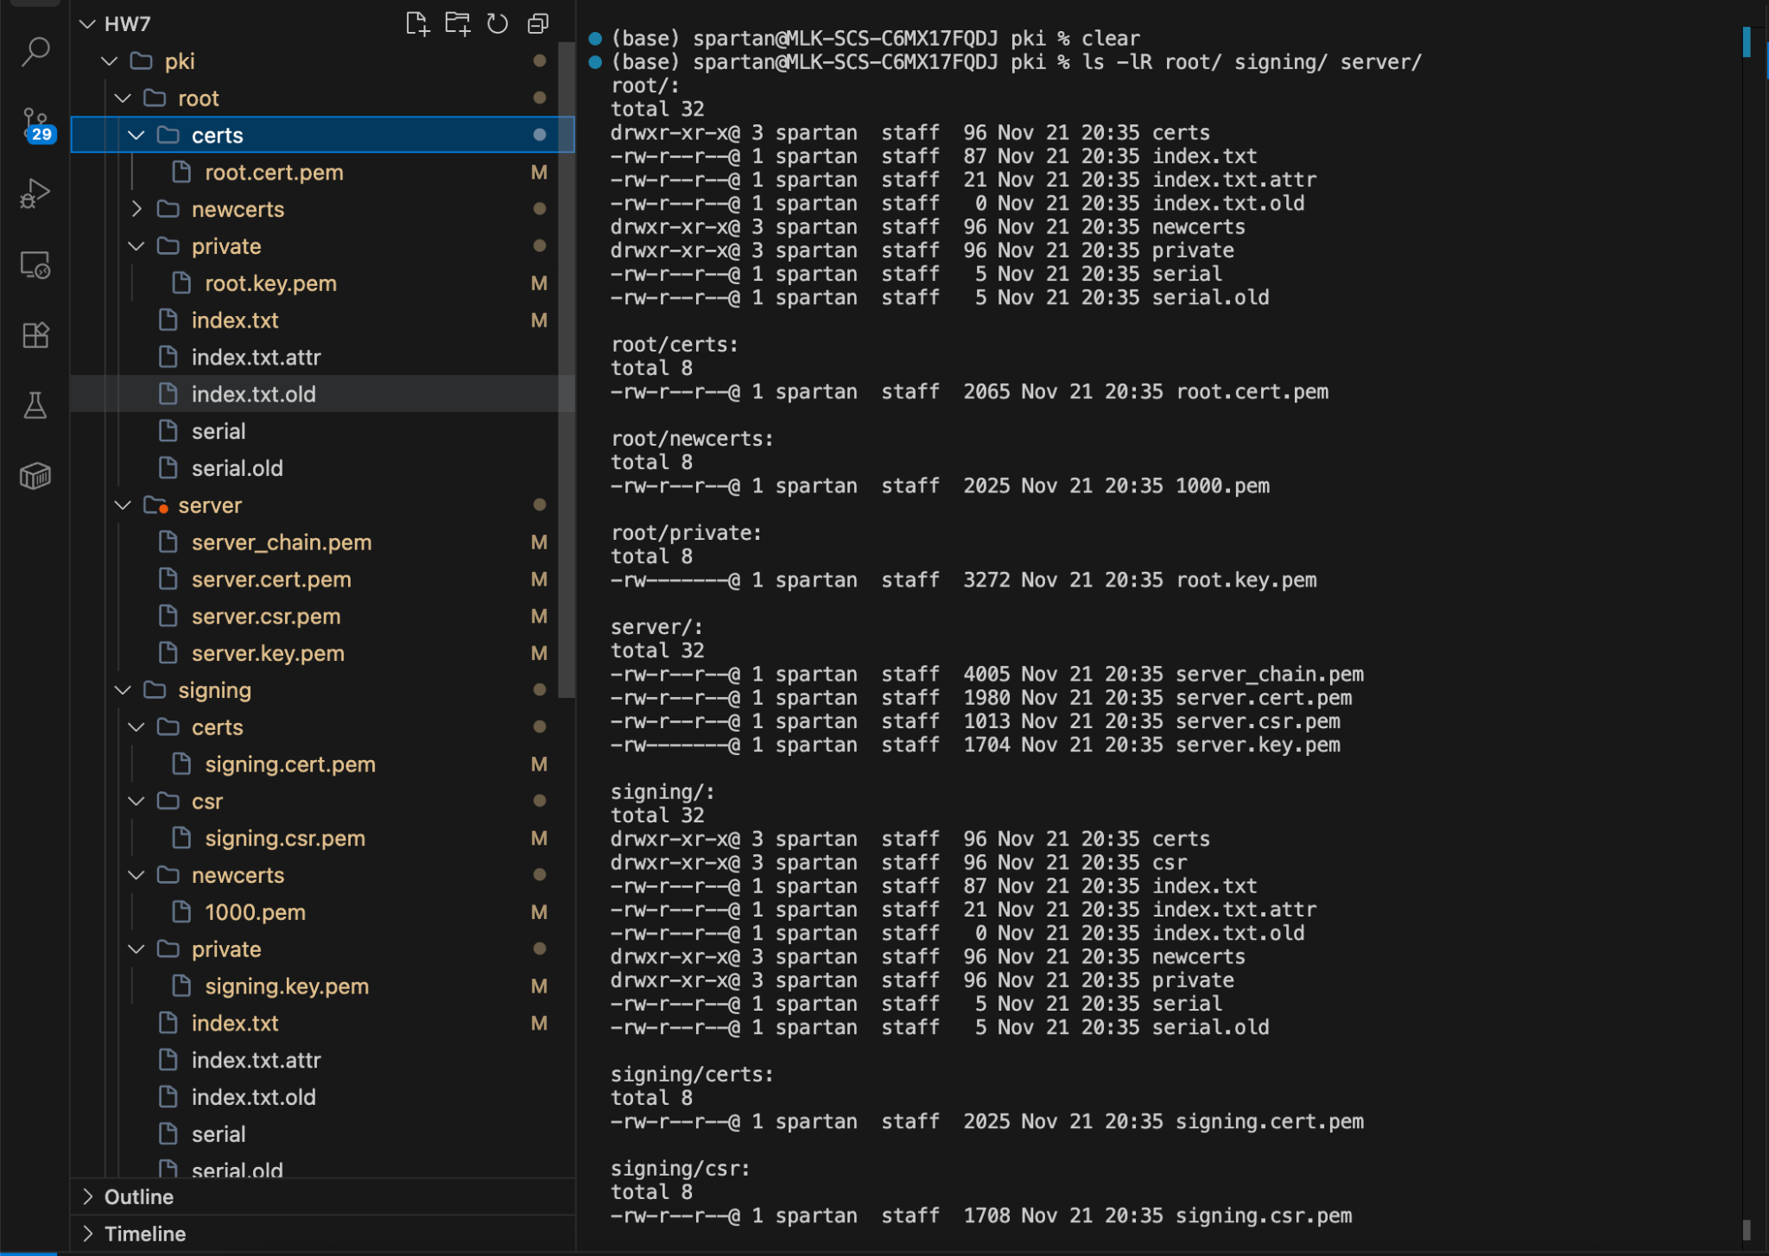  
*Figure 4: Directory listing showing all generated certificate files, private keys, and CSRs***

**Key files include: - root/private/root.key.pem - Root CA private key - root/certs/root.cert.pem - Root CA certificate - signing/private/signing.key.pem - Signing CA private key - signing/certs/signing.cert.pem - Signing CA certificate - server/server.key.pem - Server private key - server/server.cert.pem - Server certificate - server/server_chain.pem - Full certificate chain**

## 

## 

## 

## 

## 

## 

## 3. Certificate Details and Inspection

### 3.1 Root CA Certificate

**The Root CA is self-signed and serves as the trust anchor for the entire PKI:**

**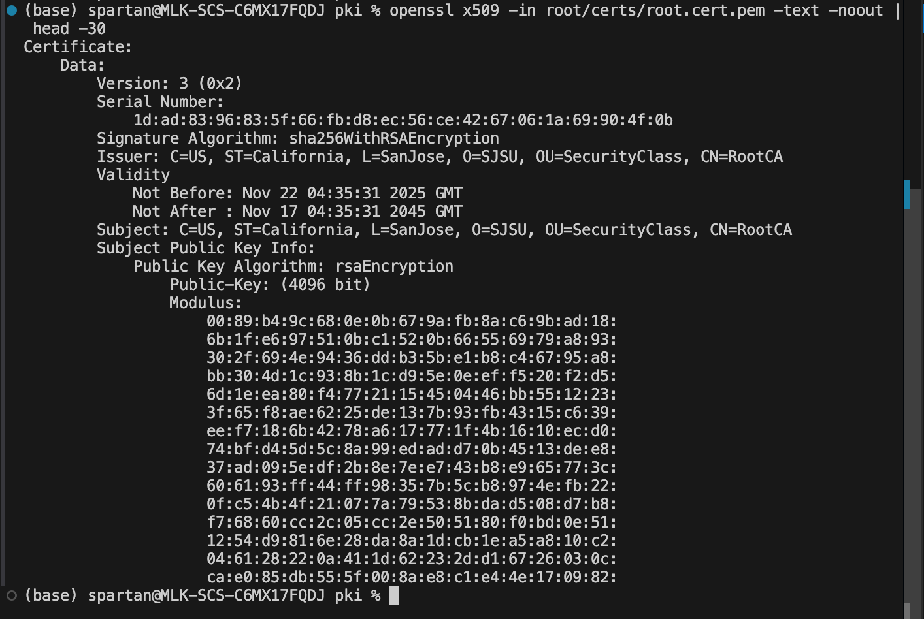  
*Figure 5: Root CA certificate details showing it is self-signed (Issuer = Subject)***

**Key details: - Subject: CN=RootCA, OU=SecurityClass, O=SJSU - Issuer: CN=RootCA (self-signed) - Validity: 20 years - Basic Constraints: CA:TRUE**

### 

### 

### 

### 

### 

### 

### 

### 

### 

### 3.2 Signing CA Certificate

**The Signing CA (intermediate CA) is signed by the Root CA:**

**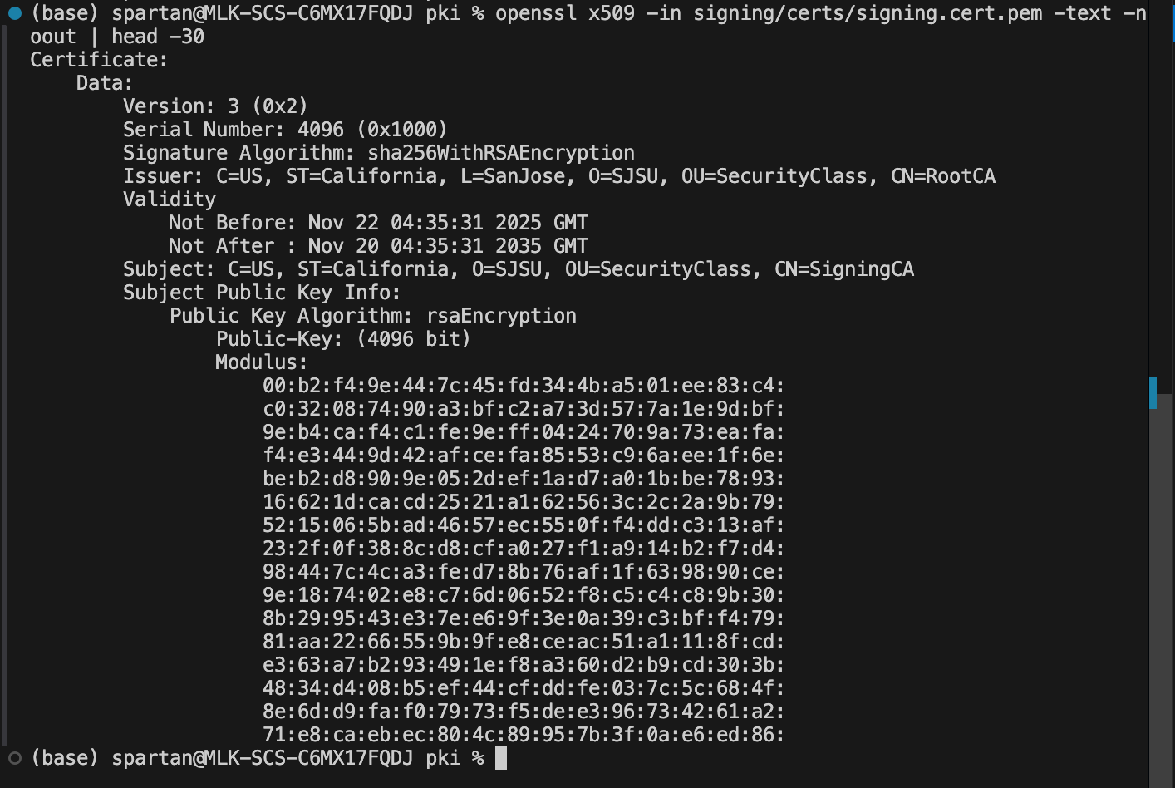  
*Figure 6: Signing CA certificate details showing it is signed by Root CA***

**Key details: - Subject: CN=SigningCA, OU=SecurityClass, O=SJSU - Issuer: CN=RootCA (signed by Root CA) - Validity: 10 years - Basic Constraints: CA:TRUE, pathlen:0**

### 

### 

### 

### 

### 

### 

### 

### 

### 

### 3.3 Server Certificate

**The Server Certificate is a leaf certificate signed by the Signing CA:**

**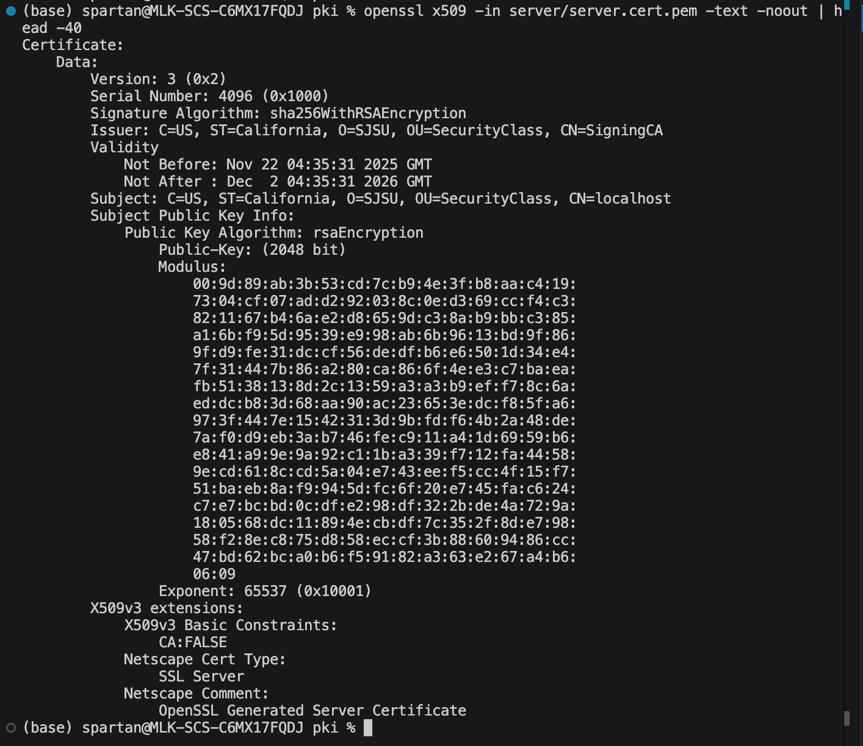  
*Figure 7: Server certificate with Subject Alternative Name (SAN) for localhost***

**Key details: - Subject: CN=localhost - Issuer: CN=SigningCA - Validity: ~1 year - SAN: DNS:localhost, IP:127.0.0.1 - Extended Key Usage: TLS Web Server Authentication**

### 3.4 Certificate Chain Verification

**The complete certificate chain was verified using OpenSSL:**

**  
*Figure 8: Certificate chain verification showing “OK” status***

**This confirms that: 1. Server certificate is signed by Signing CA 2. Signing CA is signed by Root CA 3. The entire chain of trust is valid**

## 4. Web Server Configuration

### 4.1 Server Implementation

**A Python-based HTTPS server was implemented using the http.server and ssl modules:**

**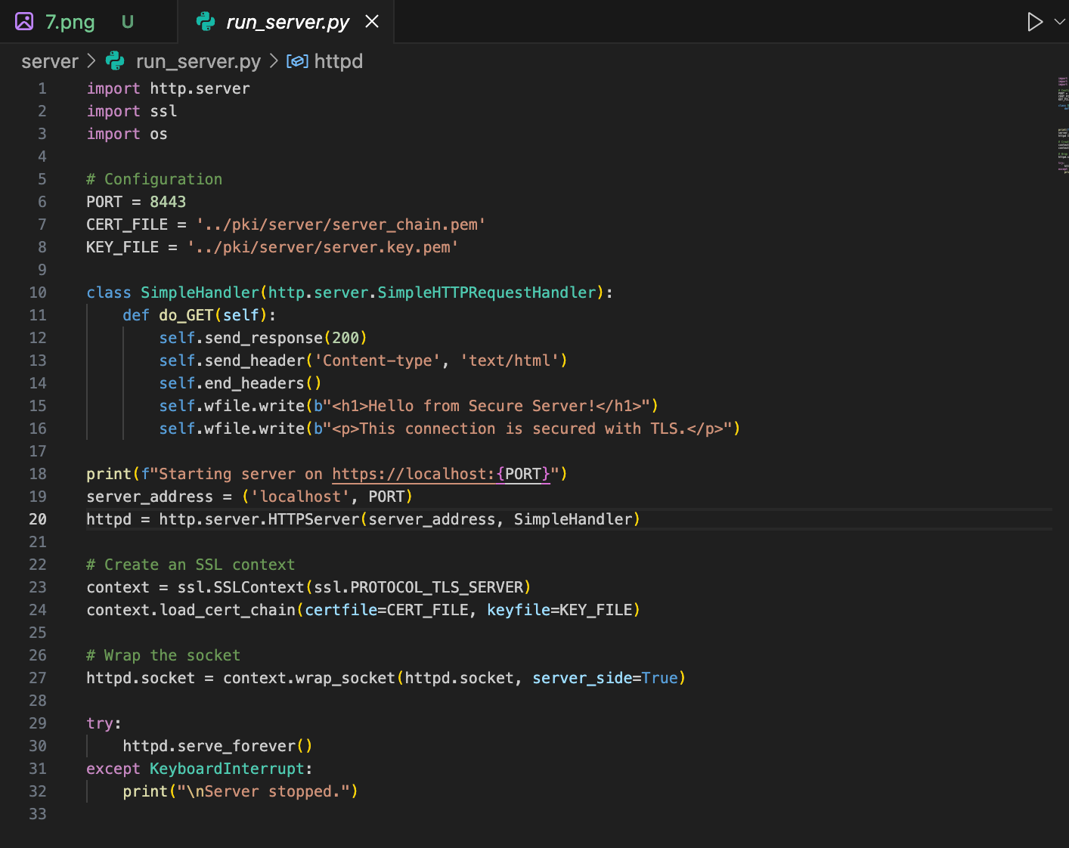  
*Figure 9: Python HTTPS server code using the generated certificates***

**The server: - Listens on port 8443 - Uses the server certificate chain - Implements TLS/SSL encryption**

### 

### 

### 

### 

### 

### 

### 4.2 Starting the Server

**The server was started and began listening for HTTPS connections:**

**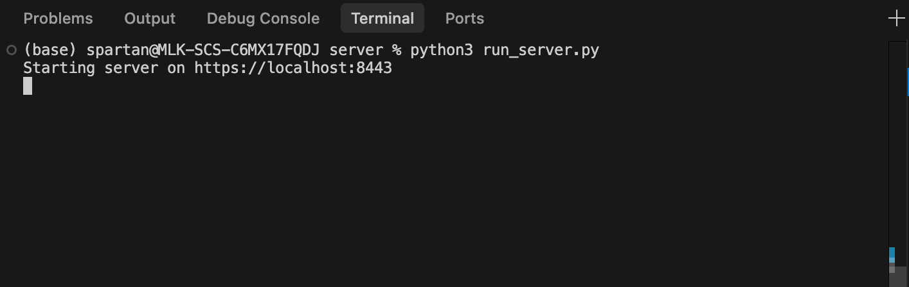  
*Figure 10: Server successfully started on https://localhost:8443***

## 5. Testing and Validation

### 5.1 Testing with curl (Command Line)

**The server was tested using curl with the Root CA certificate:**

**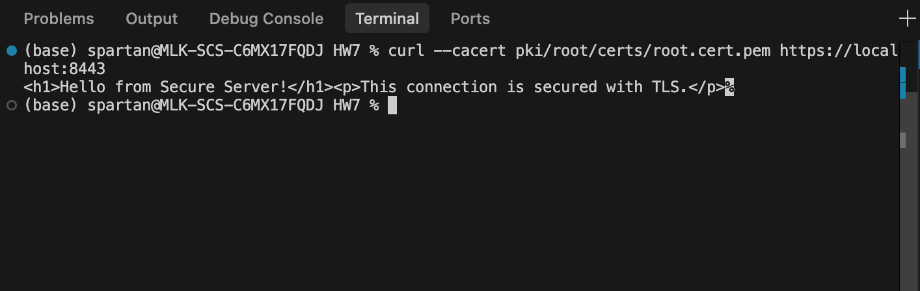*Figure 11: Successful HTTPS connection using curl, proving the certificate chain is valid***

**The --cacert flag tells curl to trust our custom Root CA. The successful response proves: - TLS handshake completed successfully - Certificate chain is valid - Server is properly configured**

### 

### 

### 

### 

### 5.2 TLS Handshake Details

**Using curl’s verbose mode shows the TLS handshake details:**

**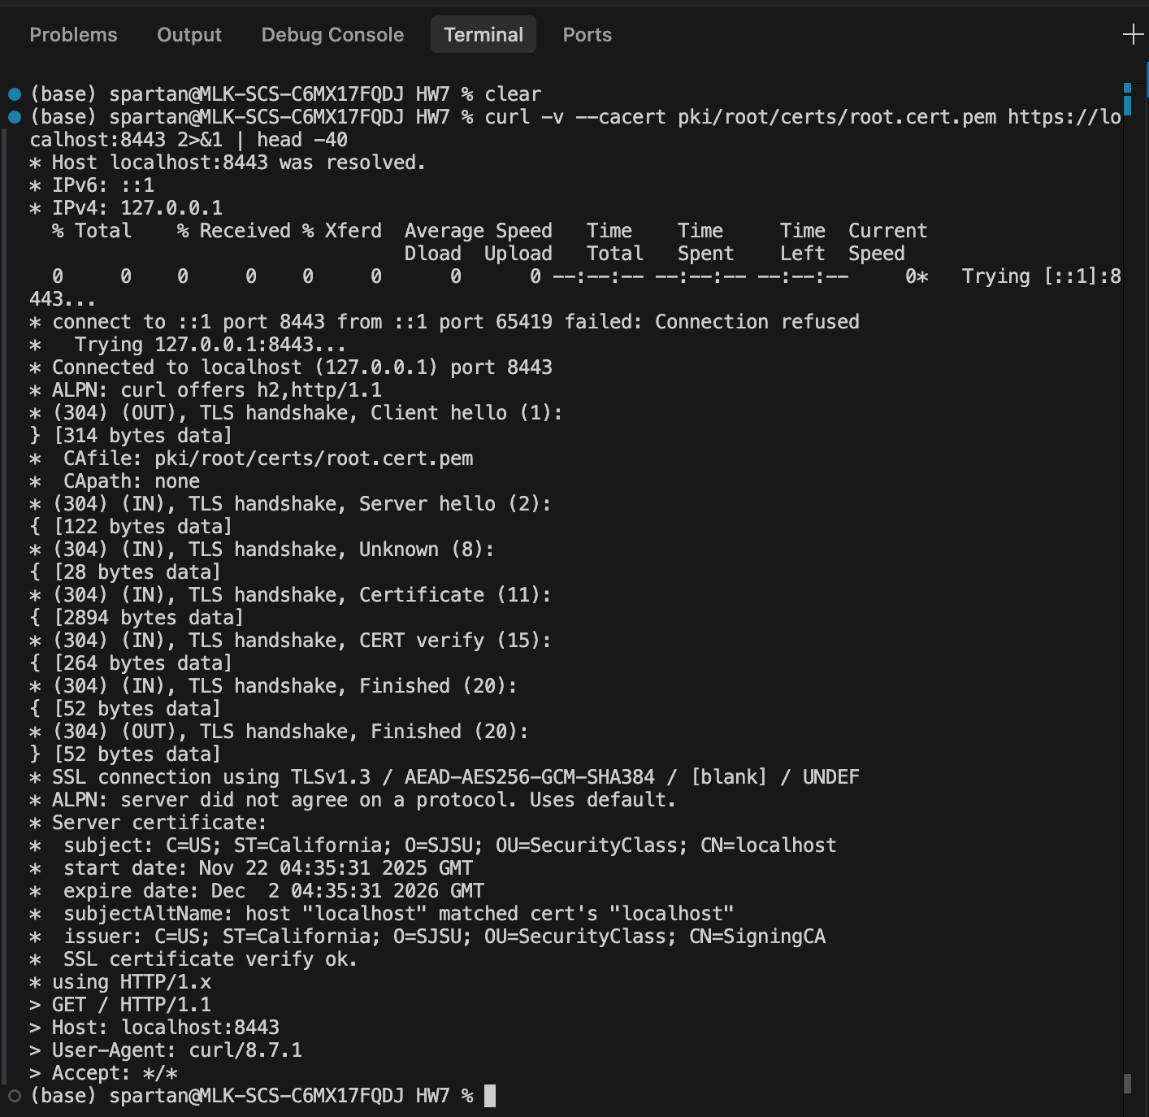  
*Figure 12: Verbose output showing TLS protocol version, cipher suite, and certificate verification***

### 

### 

### 

### 

### 

### 

### 

### 5.3 Browser Testing

#### *Browser Security Warning*

*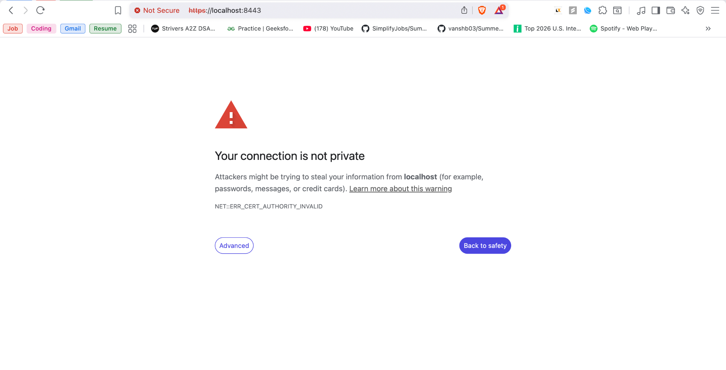****Figure 13: Browser displays security warning (expected behavior for private PKI)***

**The browser shows “Your connection is not private” because: - Our Root CA is not in the system’s trust store - Only public CAs (Let’s Encrypt, DigiCert, etc.) are pre-trusted - This is expected behavior for a private PKI**

#### *Certificate Details in Browser*

*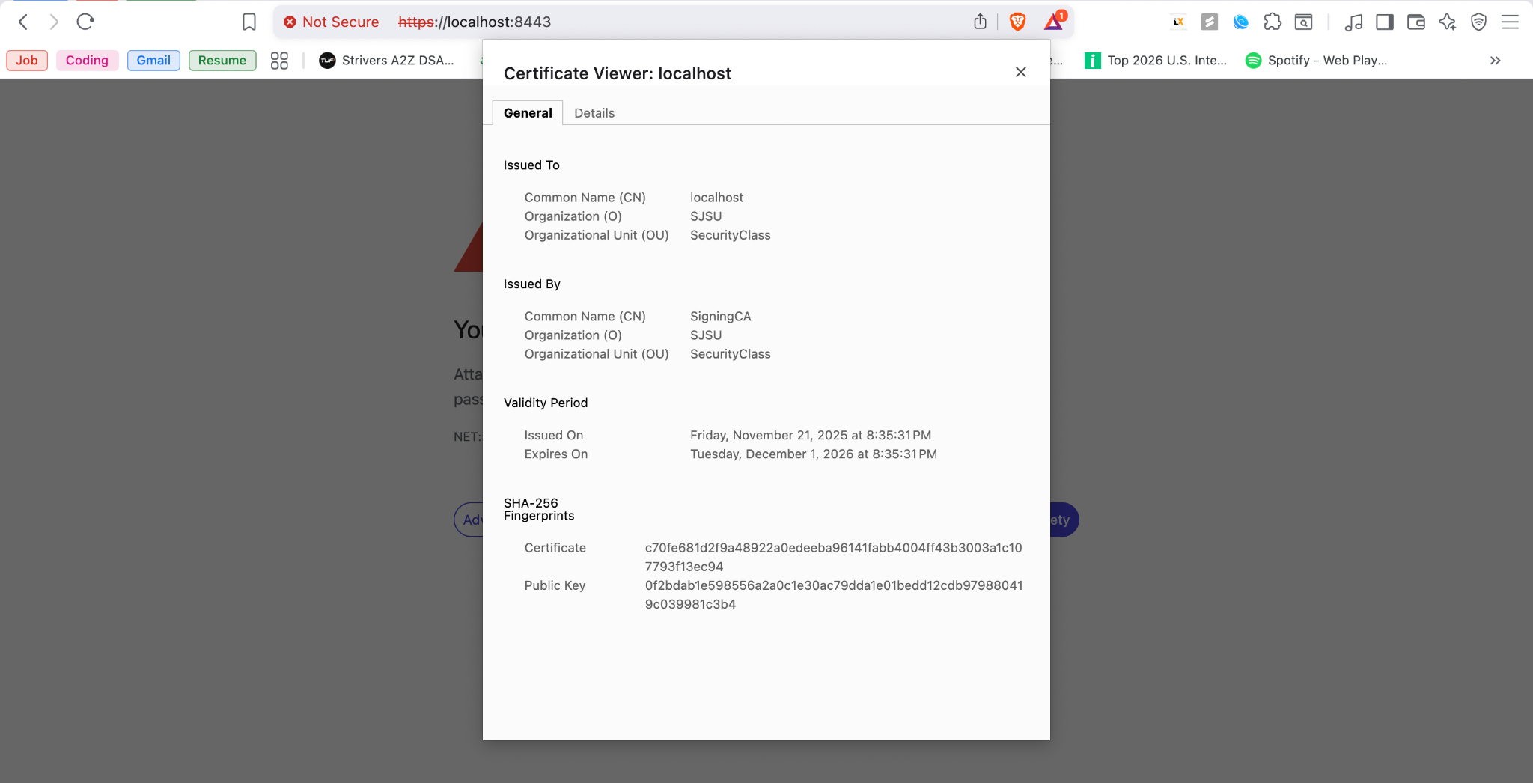****Figure 14: Certificate details visible in the browser showing proper configuration***

#### 

#### 

#### *Accessing the Secure Page*

**After proceeding past the warning, the page loads successfully:**

**  
*Figure 15: Successfully accessed the secure webpage over HTTPS***

## 

## 

## 

## 

## 

## 

## 

## 

## 

## 

## 

## 

## 6. Code Repository

### 6.1 Git Repository

**The project was version controlled using Git:**

**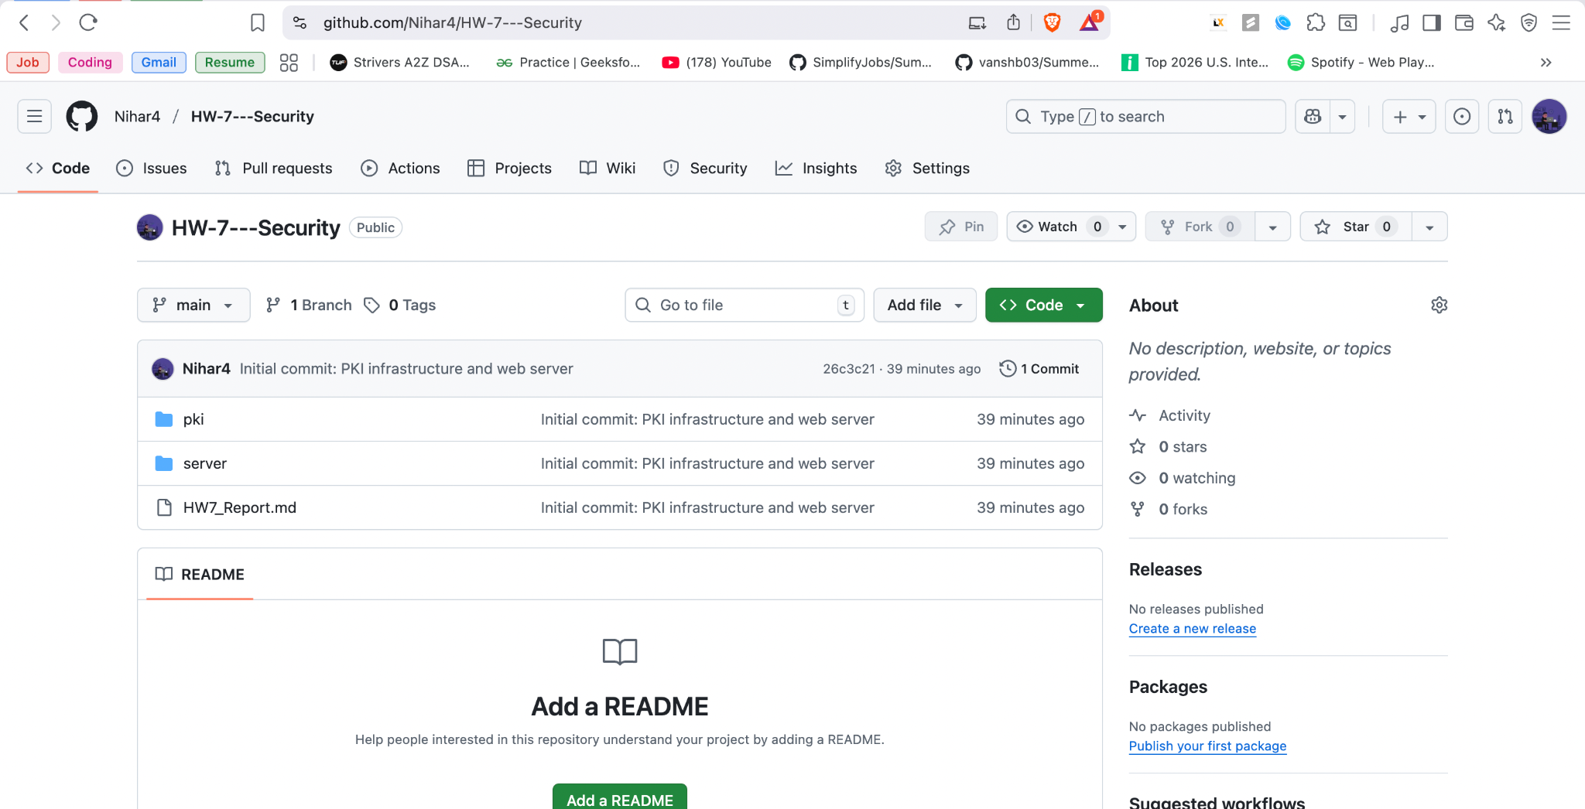  
*Figure 16: Git commit history showing project development***

### 

### 

### 

### 

### 

### 

### 

### 

### 

### 

### 

### 

### 6.2 Complete Project Structure

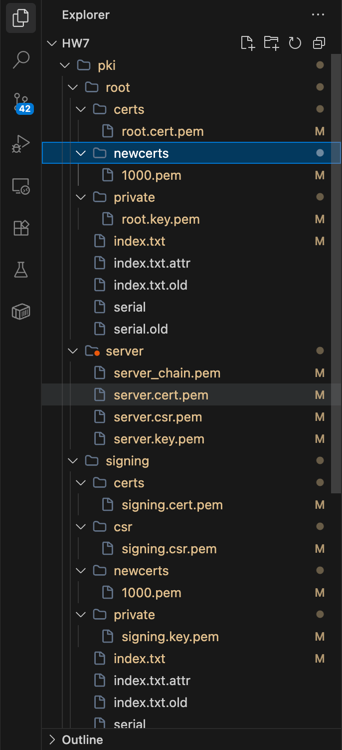

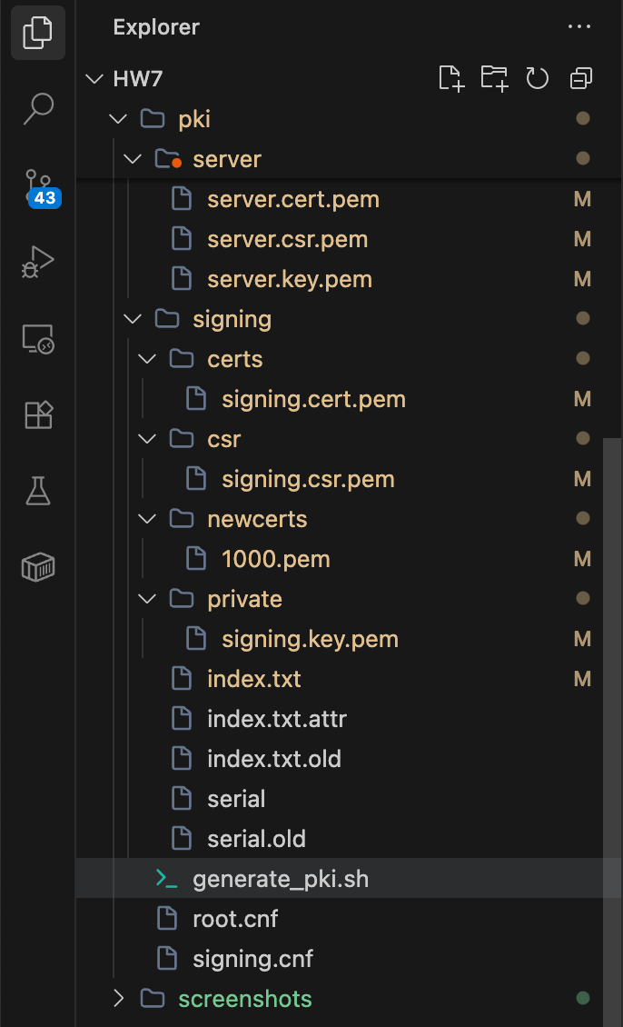  
***Figure 17: Complete file structure of the project***

## 

## 

## 

## 

## 

## 

## 7. Conclusion

**This assignment successfully demonstrated:**

1. **PKI Infrastructure: A complete 3-tier PKI was built with Root CA, Signing CA, and Server Certificate using OpenSSL. All certificates follow industry best practices with proper extensions (Basic Constraints, Key Usage, Subject Alternative Names).**
2. **Certificate Chain: The certificate chain was properly configured and verified. The server certificate is signed by the Signing CA, which is in turn signed by the Root CA, creating a valid chain of trust.**
3. **Secure Web Server: A web server was configured to use TLS/SSL encryption with the generated certificates. The server successfully handles HTTPS connections on port 8443.**
4. **Verification: Multiple verification methods were used:**

**o OpenSSL command-line verification of the certificate chain**

**o curl testing with the Root CA**

**o Browser testing showing proper TLS encryption**

**The browser security warning is expected behavior for a private PKI and does not indicate any problems with the implementation. In a production environment, the Root CA would be distributed to clients and added to their trust stores.**

## Key Commands Used

### Certificate Generation

**```bash # Generate PKI cd pki ./generate_pki.sh ```**

### Certificate Verification

**```bash openssl verify -CAfile root/certs/root.cert.pem \ -untrusted signing/certs/signing.cert.pem \ server/server.cert.pem ```**

### Start Server

**```bash cd server python3 run_server.py ```**

### Test with curl

**```bash curl –cacert pki/root/certs/root.cert.pem https://localhost:8443 ```**